Query the list of CITY names from **STATION** which have vowels (i.e., a, e, i, o, and u) as both their first and last characters. Your result cannot contain duplicates.

**Input Format**

The **STATION** table is described as follows:

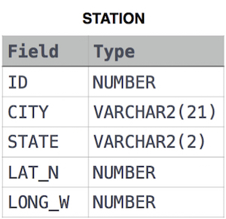

where LAT_N is the northern latitude and LONG_W is the western longitude.

Solution:

SELECT DISTINCT CITY

FROM STATION

WHERE SUBSTR(CITY,1) IN('A','E','I','O','U','a','e','i','o','u') AND SUBSTR(CITY,'LENGTH(CITY)',1) IN ('A','E','I','O','U','a','e','i','o','u');